DIGITAL TWIN WAREHOUSE MANAGEMENT
Maintaining a Live Digital Representation of a Warehouse

1. Chosen Problem Statement & Requirement Analysis

1.1 Problem Statement
Modern warehouses handle thousands of stock-keeping units across multiple zones, racks, and bins, with constant movement of goods driven by incoming shipments and outgoing orders. Managers typically rely on periodic manual stock counts and disconnected spreadsheets, which leads to stale inventory data, undetected equipment or environmental faults, and delayed decision-making. There is a need for a system that mirrors the physical warehouse in real time — a "digital twin" — so that every rack, bin, sensor reading, and order can be tracked, queried, and analyzed the instant it changes in the real world.
This project proposes a Digital Twin Warehouse Management System: a database-backed platform that continuously ingests data from warehouse sensors and operational transactions, stores it in a structured relational schema, and exposes a live, queryable representation of the warehouse's physical and operational state. The digital twin supports real-time monitoring, historical analysis, and early detection of anomalies such as overstocked bins, faulty sensors, or delayed shipments.

1.2 Project Objectives
- Maintain an always-current record of the warehouse's physical layout (warehouses, zones, racks, and bins).
- Track inventory at the individual bin level and keep stock quantities synchronized with real-world movements.
- Continuously capture sensor data (e.g., weight, temperature, RFID location) to reflect real-time physical conditions.
- Record orders, order fulfilment, and shipments so that customer-facing operations are tied to physical stock.
- Detect and log anomalies or threshold breaches as alerts for warehouse staff.
- Preserve periodic snapshots of the overall warehouse state to support historical playback and analytics.

1.3 Functional Requirements
- The system shall allow creation and maintenance of warehouses, zones, racks, and bins in a hierarchical structure.
- The system shall record product master data and track quantities of each product held in each bin.
- The system shall ingest sensor readings and associate them with the zone/bin in which the sensor is installed.
- The system shall generate an alert whenever a sensor reading breaches a defined threshold or a sensor fails.
- The system shall record customer orders, the products/quantities in each order, and the resulting shipments.
- The system shall periodically persist a snapshot of overall warehouse state for the digital twin's historical view.
- The system shall allow authorized staff (employees) to be assigned to specific zones for accountability.

1.4 Non-Functional Requirements
- Data consistency: stock levels and sensor states must remain accurate even under frequent, concurrent updates.
- Near real-time performance: sensor readings and stock changes should be reflected with minimal latency.
- Scalability: the schema should accommodate growth in the number of zones, bins, products, and sensors.
- Auditability: historical snapshots and readings must be retained for traceability and reporting.
- Security: access to operational data should be restricted based on employee roles.

1.5 Scope
The scope of this project covers the data layer of a digital twin: the entities required to represent warehouse structure, inventory, sensors, alerts, employees, equipment, and order fulfilment, along with the relationships that keep them synchronized. Front-end visualization and real-time streaming infrastructure are treated as consumers of this data layer and are described conceptually in the workflow section, but the core deliverable is the database design that makes the digital twin possible.

2. Entity–Relationship (ER) Diagram
The ER diagram below models the warehouse as a hierarchy (Warehouse → Zone → Rack → Bin) that anchors every other entity. Inventory is tracked through the InventoryItem associative entity linking Bin and Product. Sensors are attached to zones and generate SensorReading and Alert records. Employees and Equipment are also assigned to zones. Order fulfilment is modelled through Order, OrderItem, and Shipment, with OrderItem linking Order and Product. Periodic DigitalTwinSnapshot records capture the overall state of a Warehouse over time.
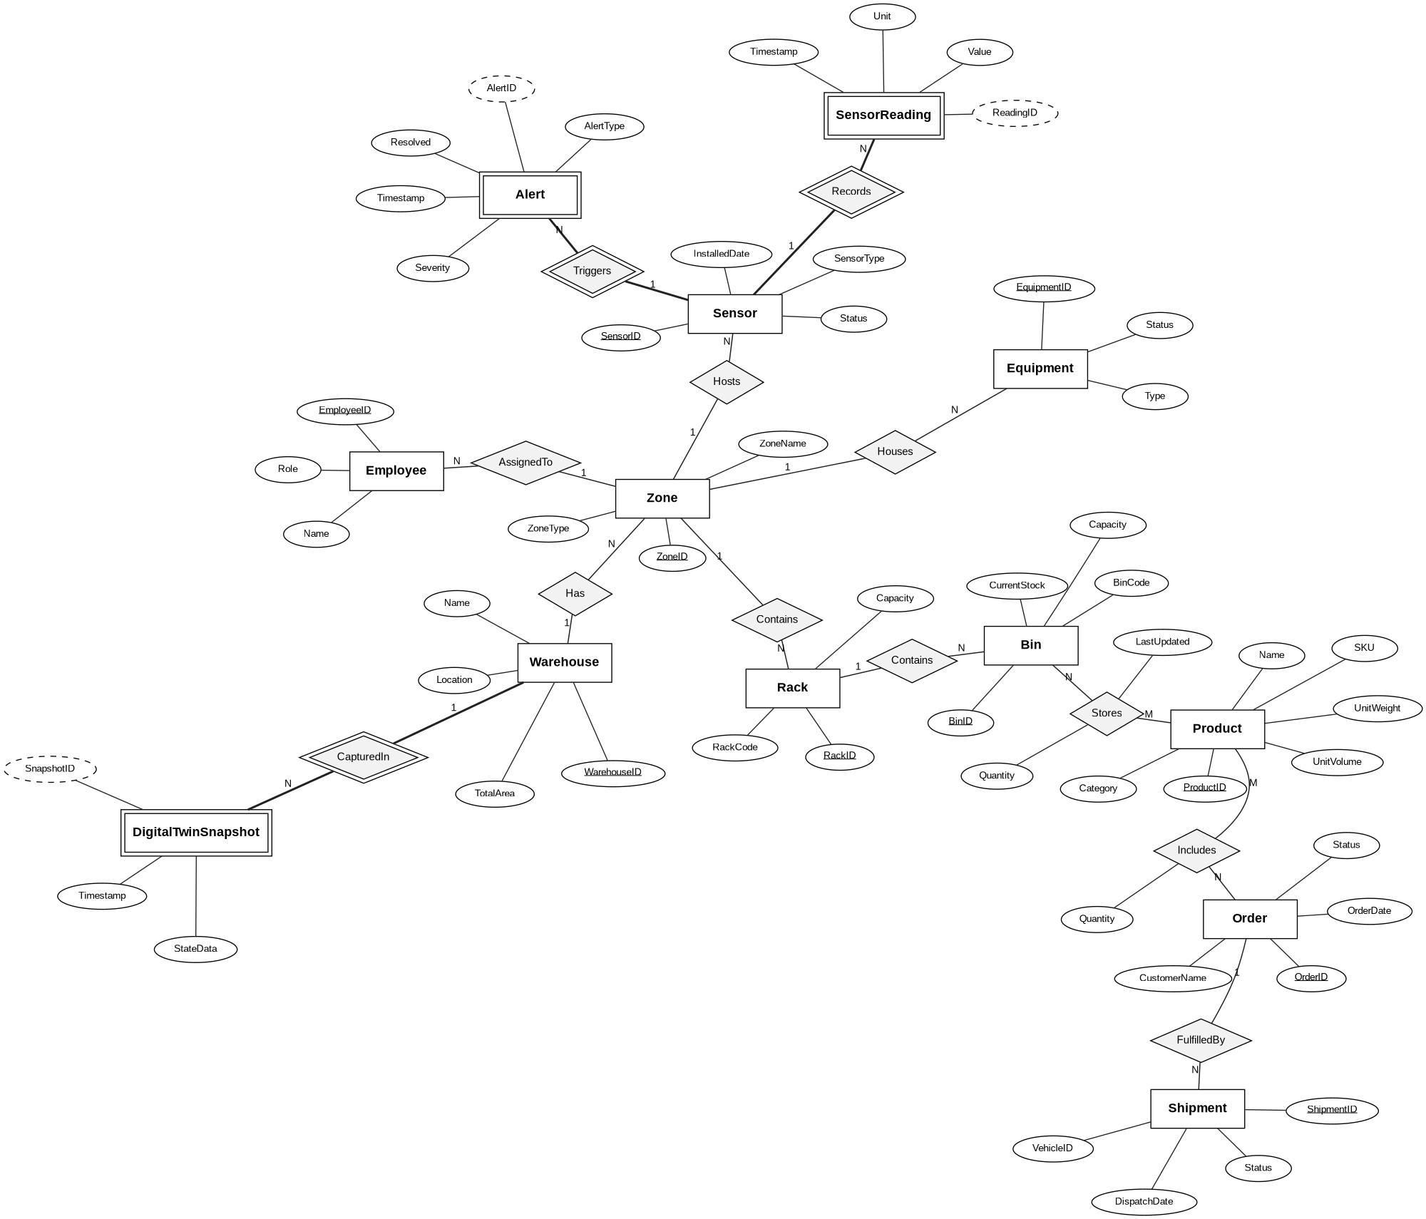
Figure 1: Entity–Relationship diagram for the Digital Twin Warehouse Management System

2.1 Entities and Relationship Summary
Relationship | Cardinality & Description
Warehouse — Zone | 1 : N — A warehouse contains many zones.
Zone — Rack | 1 : N — A zone contains many racks.
Rack — Bin | 1 : N — A rack contains many bins.
Bin — InventoryItem | 1 : N — A bin holds many inventory-item records.
Product — InventoryItem | 1 : N — A product can appear in many bins (M:N between Bin and Product via InventoryItem).
Zone — Sensor | 1 : N — A zone hosts many sensors.
Sensor — SensorReading | 1 : N — A sensor produces many readings over time.
Sensor — Alert | 1 : N — A sensor can trigger many alerts.
Zone — Employee | 1 : N — A zone has many employees assigned to it.
Zone — Equipment | 1 : N — A zone contains many pieces of equipment.
Order — OrderItem | 1 : N — An order contains many order-item lines.
Product — OrderItem | 1 : N — A product can appear on many order-item lines (M:N between Order and Product via OrderItem).
Order — Shipment | 1 : N — An order may be fulfilled through one or more shipments.
Warehouse — DigitalTwinSnapshot | 1 : N — A warehouse accumulates many snapshots over time.

3. Conversion of the ER Diagram into Relational Design
Each entity in the ER diagram is mapped directly to a relational table, with the entity's identifier becoming the table's primary key. One-to-many relationships (e.g., Warehouse–Zone, Zone–Rack) are implemented by placing a foreign key on the "many" side. Many-to-many relationships that were already resolved using associative entities in the ER diagram — InventoryItem (Bin ↔ Product) and OrderItem (Order ↔ Product) — carry forward as ordinary tables holding both foreign keys plus their own descriptive attributes. The resulting schema is in Third Normal Form: every non-key attribute depends only on its table's primary key, with no transitive dependencies across tables.
Table: Warehouse
Attribute | Data Type | Key / Constraint
WarehouseID | INT | Primary Key
Name | VARCHAR(100) | Not Null
Location | VARCHAR(150) | Not Null
TotalArea | DECIMAL(10,2) | -
Table: Zone
Attribute | Data Type | Key / Constraint
ZoneID | INT | Primary Key
WarehouseID | INT | Foreign Key → Warehouse
ZoneName | VARCHAR(100) | Not Null
ZoneType | VARCHAR(50) | e.g. Storage, Loading
Table: Rack
Attribute | Data Type | Key / Constraint
RackID | INT | Primary Key
ZoneID | INT | Foreign Key → Zone
RackCode | VARCHAR(30) | Unique
Capacity | INT | Not Null
Table: Bin
Attribute | Data Type | Key / Constraint
BinID | INT | Primary Key
RackID | INT | Foreign Key → Rack
BinCode | VARCHAR(30) | Unique
Capacity | INT | Not Null
CurrentStock | INT | Default 0
Table: Product
Attribute | Data Type | Key / Constraint
ProductID | INT | Primary Key
SKU | VARCHAR(40) | Unique, Not Null
Name | VARCHAR(120) | Not Null
Category | VARCHAR(60) | -
UnitWeight | DECIMAL(8,2) | -
UnitVolume | DECIMAL(8,2) | -
Table: InventoryItem
Attribute | Data Type | Key / Constraint
InventoryID | INT | Primary Key
BinID | INT | Foreign Key → Bin
ProductID | INT | Foreign Key → Product
Quantity | INT | Not Null
LastUpdated | DATETIME | Not Null
Table: Sensor
Attribute | Data Type | Key / Constraint
SensorID | INT | Primary Key
ZoneID | INT | Foreign Key → Zone
SensorType | VARCHAR(50) | e.g. RFID, Temperature
Status | VARCHAR(20) | Active / Inactive / Faulty
InstalledDate | DATE | -
Table: SensorReading
Attribute | Data Type | Key / Constraint
ReadingID | INT | Primary Key
SensorID | INT | Foreign Key → Sensor
Timestamp | DATETIME | Not Null
Value | DECIMAL(10,3) | Not Null
Unit | VARCHAR(20) | -
Table: Alert
Attribute | Data Type | Key / Constraint
AlertID | INT | Primary Key
SensorID | INT | Foreign Key → Sensor
AlertType | VARCHAR(50) | -
Severity | VARCHAR(20) | Low / Medium / High
Timestamp | DATETIME | Not Null
Resolved | BOOLEAN | Default False
Table: Employee
Attribute | Data Type | Key / Constraint
EmployeeID | INT | Primary Key
ZoneID | INT | Foreign Key → Zone
Name | VARCHAR(100) | Not Null
Role | VARCHAR(60) | -
Table: Equipment
Attribute | Data Type | Key / Constraint
EquipmentID | INT | Primary Key
ZoneID | INT | Foreign Key → Zone
Type | VARCHAR(50) | e.g. Forklift, AGV
Status | VARCHAR(20) | Idle / In-Use / Maintenance
Table: Order
Attribute | Data Type | Key / Constraint
OrderID | INT | Primary Key
CustomerName | VARCHAR(120) | Not Null
OrderDate | DATE | Not Null
Status | VARCHAR(30) | Pending / Shipped / Delivered
Table: OrderItem
Attribute | Data Type | Key / Constraint
OrderItemID | INT | Primary Key
OrderID | INT | Foreign Key → Order
ProductID | INT | Foreign Key → Product
Quantity | INT | Not Null
Table: Shipment
Attribute | Data Type | Key / Constraint
ShipmentID | INT | Primary Key
OrderID | INT | Foreign Key → Order
DispatchDate | DATE | -
Status | VARCHAR(30) | Preparing / In-Transit / Delivered
VehicleID | VARCHAR(30) | -
Table: DigitalTwinSnapshot
Attribute | Data Type | Key / Constraint
SnapshotID | INT | Primary Key
WarehouseID | INT | Foreign Key → Warehouse
Timestamp | DATETIME | Not Null
StateData | JSON / TEXT | Serialized warehouse state
Note on normalization:
All descriptive attributes depend solely on their own table's primary key (2NF/3NF satisfied). Repeating hierarchy links (Warehouse→Zone→Rack→Bin) are expressed purely through single foreign keys rather than duplicated location fields, and the many-to-many links between Bin/Product and Order/Product are resolved through InventoryItem and OrderItem respectively, avoiding any composite or repeating-group attributes.

4. Explanation of the Initial Workflow of the Proposed Project
The digital twin operates as a closed loop between the physical warehouse and its data representation. The diagram below traces how a physical event becomes a piece of stored, queryable, and visualized information, and how insights derived from that information feed back into physical action.

4.1 Step-by-Step Workflow
- Physical activity occurs in the warehouse — goods are moved between bins, forklifts operate, and environmental conditions (temperature, humidity) fluctuate across zones.
- IoT sensors and scanners (RFID tags, weight sensors, temperature probes, barcode scanners) continuously observe these physical events and generate raw readings.
- The data ingestion layer receives these readings — along with transactional events such as new orders — validates them, and routes them toward persistent storage.
- The central relational database stores this information using the schema defined in Section 3: bin-level stock via InventoryItem, sensor readings via SensorReading, and any threshold violations as Alert records.
- The digital twin engine reads from the database to synchronize its in-memory model of the warehouse, running lightweight checks (e.g., stock-vs-capacity, sensor anomaly detection) and periodically writing a DigitalTwinSnapshot for historical continuity.
- The visualization dashboard queries the twin engine/database to present a live 2D/3D view of the warehouse, current stock levels, active alerts, and key performance indicators.
- Warehouse managers and operators view this dashboard to make informed decisions — reallocating stock, dispatching staff to resolve an alert, or approving a shipment — which in turn changes the physical warehouse, closing the loop.

4.2 Why This Workflow Supports a Digital Twin
Because every physical change is captured at its source (sensor or transaction) and immediately persisted against the relational schema, the database itself becomes a continuously updated mirror of the warehouse rather than a static record. The DigitalTwinSnapshot table additionally allows the system to "rewind" to any earlier point in time, which is a defining characteristic of a true digital twin as opposed to a simple live dashboard. This initial workflow forms the foundation onto which further features — predictive analytics, simulation of layout changes, or automated restocking — can be layered in later stages of the project.

